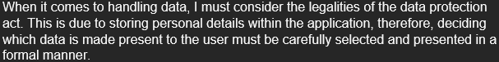

HND Computing:

Software Development

Graded unit 2

H48W35

Planning Documentation

Content Page

1. Interpretation of project brief
2. Functional/Non-Functional Requirements
   1. *Top Level use case diagram*
3. Information gathered/Researched
4. Aims of the project Assessment
5. Resources/Materials required
6. Information sources used

## Interpretation of the Project Brief

The project I have been given is to design and develop a program which will allow coaches and high-level members (Secretary) at the rugby club to track statistics, skills, games, and members at the club. This app should contain a professional GUI design, while staying in line with the general principles of graphic user interface design.

This application should contain a login system which can allow Coaches to login into the app and display options to view and edit players details like, skills obtained through training sessions. Coaches should also have the ability to record games that have been played, recording data like the final score, additional comments & the team that played.

Data like statistics, skills obtained etc. should be made persistent throughout the application allowing the application to be closed and then continuing from where the user had recently stopped.

The application should also consider if players have not already signed a health and safety form allowing them to compete for that year.

When it comes to handling data, I must consider the legalities of the data protection act. This is due to storing personal details within the application, therefore, deciding which data is made present to the user must be carefully selected and presented in a formal manner.

The overall design and development of this application should be to help coaches judge who from each team will progress onto potential development schemes and decide what player is fit enough for the squad. Coaches should also have the ability to update a players skill level and store training session details like what the individual took part in and what skills were gained or needing refined.

## 

## Functional/Non-Functional Requirements

# Functional:

* System must check if members are registered to SRU (Enter users SRU number)
* Allow each coach in every age group to track their players details within that age group (Skill Category, Skills, skill level, comments, name, and the squad their apart of)
* Check if junior players have signed the consent form for each season. This must be signed by a legal guardian.
* Coaches keep records of player profiles. These will be used to organise appropriate training session for those players
* Player profiles must include details about estimated skill level, skills, a category for each skill & the squad they are a part of.
* Record training sessions activities and game details. This will include any comments about the match and the scoring details (Points for & against)
* Administrators must be only allowed to add new Coaches & users

# Non-Functional:

* Deadlines – The overall scope of this project is to create a working prototype that matches the clients requests and is completed within the time limit we have been assigned.
* Reliability – The program should be reliable in storing data and making it persistent. Any instances of data loss could result in players data becoming corrupt, or just losing chunks of data. Therefore, the application must be reliable in storing data, especially when it comes to storing personal details of players and coaches.
* Useability – The overall app must be easy to use for the coaches to use. Due to target audience being rugby coaches and not people that are potentially tech savvy the application must be presentable and provide an ease of use. If a user gets lost within the system, then the design of the application must be considered and refined to support the needs of coaches. This will require a GUI – Graphical User Interface – to support the plan of allowing users to easily navigate the system and present a formal application.
* Testing Performance & Security – Within the Simply Rugby application we will be storing personal data of players and coaches. Their data will be protected by the Data protection act. It is important that we respect and take priority in storing their data safely. Overall performance of the application must be smooth and seamless, allowing users to navigate and change details within experiencing and bugs or delays in the application.
* Legal Constraints: Data - Data held within the program as mentioned within the “Testing Performance & Security” section mentioned it is required that users personal data is stored correctly. Personal data that is linked to a member of the club must be held for no longer than necessary. If a member of the Rugby club was to leave, their data must be removed in order for the data subject to remain anonymous.

## Top-Level Use Case Diagram

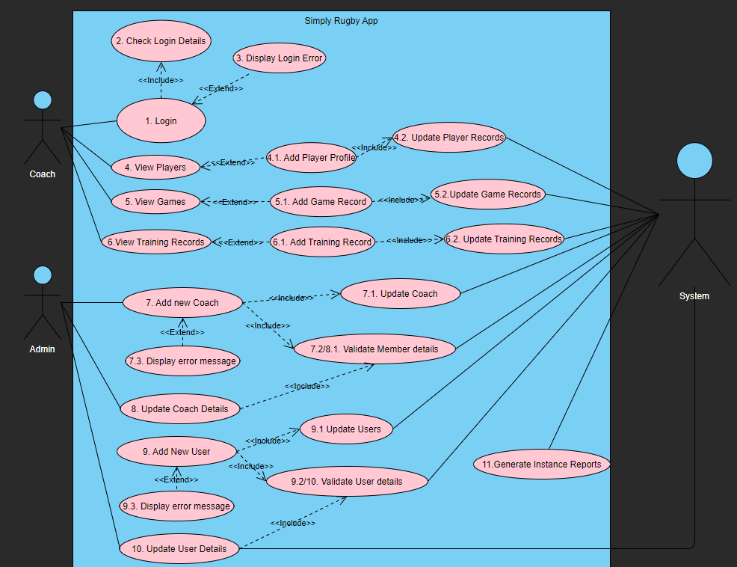

## Information Gathered/Researched

After reading over the brief and gaining questions from the client, I was able to gather some information about what the system is requiring:

* Track Rugby players of all age groups (Mini, Midi & Senior levels)
* Store details of each player in the squad
* Track development of each players skills in the squad
* Store Game details
* Training session details
* Store details of players for the membership secretary to send relevant information to the players at the club

I also obtained answers from the chairman after asking questions regarding how the system will function. the extra question we obtained from the chairman, this will help me develop a deeper understanding of what the application will look like and how it will function.

Questions and answers from the chairman can be found in this good drive document: <https://docs.google.com/document/d/1uuxVWmDEzrx2mdPaVe1yjH1Qf5XU-2GT/edit>

# Research

After carrying out research on other application or items that track players statistics. I came across **StatSports.**  Stat Sports is a vest which players will wear across their chest with a device attached to the back of the vest.

This will track players movement and provide a heat map of where the player has covered the most ground. It will also track every collision the player has had on the field alongside providing statistics on every scrum, timing differentials and return to feet stats for each individual player.

With this technology, it can also provide positional analysis showing heatmaps, sprint maps and positional replay and illustrations of where a player has travelled.

Swing Java Software

This software will allow me to develop a professional GUI interface for our users to use. Swing is a part of the Java foundation class which is used to develop graphical user interfaces for window-based applications.

# Aims of the project Assessment

Throughout the development of the Simply Rugby application, there are specific requirements that must be met, those are:

* Professional GUI design that provides ease of use to the users
* Allow users to login to gain access to the system
* Data must be made persistent throughout the application
* Allow certain users to edit data within the system and save their changes
* Application must comply with the Data Protection act. Users data must be held with care and only certain data should be shown to a user.
* Appropriate security measures when logging, i.e., permissions for different users
* Coaches should only be shown the team that they coach for security/Data protection reasons.
* Ensure that all players within the team have been registered with SRU (Scottish Rugby Union).
* Allow for coaches to keep records/profiles of players
* Display profiles & records appropriately, ensuring the proper stats are displayed clearly for the user/coaches
* If the design is a success coaches that use the system should be able to judge clearly on what a player must improve upon based on the statistics displayed

# Resources/Materials required

In order to develop and design the application I will require certain resources to succeed in developing and designing a functional app.

These resources are:

Eclipse – This is an IDE – Integrated Development Environment – This will aid in developing the functionality of the website and also implementing the design of the application.

Visual Paradigm Online – This a web application which will allow me to develop top level use case diagrams and conceptual class diagrams. This will aid in the developing the design side of the application.

Google Chrome – This will help in the researching of other rugby applications and developing my knowledge of Rugby itself.

Microsoft Word – Microsoft word will help in building the project plan and developing a professional design document that will display overall planning, functional/Non-functional requirements that are required.

Java Swing – This will be used within the Eclipse IDE to create a formal Graphical User Interface for our users.

Draw.io – This will allow me to develop class diagrams & GUI wireframes to help the implementation and designing of the application throughout development.

# Information sources used

**SRU (Scottish Rugby Union)** – This is the governing body from Scottish Rugby. It is responsible for the under 16s to under 20s and the two professional teams Glasgow warriors & Edinburgh rugby – <https://www.scottishrugby.org/>

**Statsport.com** – This is website where they produce STATSports Apex device in order track player movements, scrum analysis & collision detection. This is similar to what we are developing, it will help get a better idea of what kind of statistics to store and display to the coaches - <https://statsports.com/>

**JavaPoint.com** – This website goes over the Java Swing implementation and how we can build a GUI within our application. - <https://www.javatpoint.com/java-swing>

Project Plan

Scheduled Tasks for each stage:

|  |  |  |  |  |  |  |  |
| --- | --- | --- | --- | --- | --- | --- | --- |
| Task No. | Task Name | Time Needed | Start | End | Dependencies | Deliverables | Resources |
| 1 | **Planning & Design** | 10weeks | 13/02/2022 | 29/05/22 |  |  |  |
| 1.1 | **Part A: Inception Phase** |  | 13/02/2022 | 10/03/22 |  |  |  |
| 1.2 | Receive Simply Rugby brief | 0 days | 13/02/22 | 23/02/22 |  |  |  |
| 1.3 | Gather Question for client | 10 days | 13/02/22 | 23/02/22 |  |  |  |
| 1.4 | Submit Questions for client | 0 Days | 23/02/22 | 23/02/22 | 1.3 | Client Questions | Microsoft Word |
| 1.5 | Receive feedback from client | 0 Days | 23/03/22 | 23/03/22 | 1.4 |  |  |
| 1.6 | Develop Inception plan document (Including Top-Level Use Case diagram) | 3 weeks | 23/02/22 | 10/03/22 | 1.5 |  | Microsoft Word/Visual Paradigm |
| 1.7 | Develop Top-Level-Class Diagram | 3 weeks | 23/02/22 | 10/03/22 | 1.5 |  | Draw.io |
| 1.8 | Develop Project plan | 3 weeks | 23/02/22 | 10/03/22 | 1.5 |  | Microsoft Word |
| **2** | **Solution Planning** | 19 days | 10/03/22 | 29/03/22 | 1 |  |  |
| **2.1** | **Create Business Model (Top Level Use Case Diagram** | 1 week | 10/03/22 | 17/03/22 |  |  | Visual Paradigm |
| **2.2** | **Static Model Class Diagram** | 1 week | 10/03/22 | 17/03/22 | 2.1 |  | Draw.io |
| **2.3** | **Develop Sequence Diagram** | 3 days | 17/03/22 | 20/03/22 | 2.2 |  | WebSequenceDiagrams |
| **2.4** | **Develop Wireframes for GUI design** | 1 week | 20/03/22 | 27/03/22 | 2.3 |  | Draw.io |
| **2.5** | **Produce Solution Planning document** | 2 days | 27/03/22 | 29/03/22 | 2.4,2.3,2.1,2.1 |  | Microsoft Word |
| **3** | **Implementation** | 36 days | 29/03/22 | 05/05/22 | 2 |  |  |
| **3.1** | **Develop Simply Rugby Application** | 36 Days | 29/03/22 | 05/05/22 |  |  | Eclipse IDE |
| **4** | **Testing** |  | 05/05/22 | 19/05/22 | 3 |  |  |
| **4.1** | **Develop test Plan** | 1 day | 05/05/22 | 06/05/22 |  |  | Microsoft Word |
| **4.2** | **Test run Application** | 1 day | 06/05/22 | 07/05/22 |  |  | Microsoft Word, Eclipse |
| **4.3** | **Debug application** | 1 week | 07/04/22 | 19/05/22 | 4.1,4.2 |  | Eclipse |
| **5** | **Documentation** | 1 week & 5 days | 19/05/22 | 31/05/22 | 4 |  |  |
| **5.1** | **Produce Documentation** | 2 days | 19/05/22 | 21/05/22 |  |  | Microsoft Word |
| **5.1.1** | **Produce Portfolio Evidence** | 2 days | 19/05/22 | 21/05/22 |  |  | Microsoft Word |
| **5.2** | **Produce Evaluation** | 10 days | 21/05/22 | 31/05/22 | 5.1,5.1.1 |  | Microsoft Word |

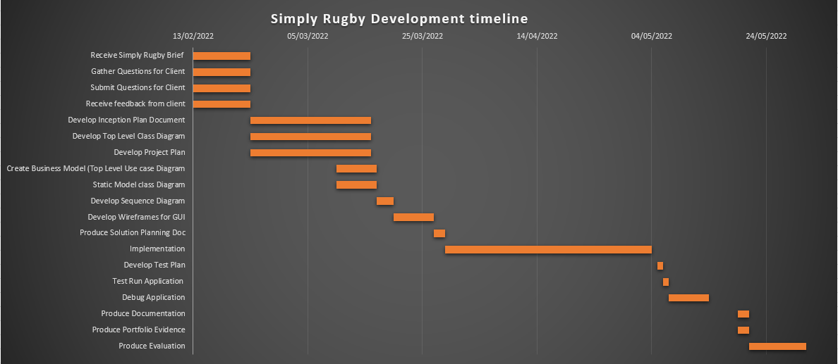**Simply Rugby Development Timeline Gantt Chart:**